Assignment 1
Total Marks: 50

Problem Statement
Design and implement a Bus Ticket Booking & Billing System for a transportation company. The system must allow users to book bus tickets, select seats, receive invoices, and make payments. The project must be implemented using Object-Oriented Programming (OOP) principles and must demonstrate proper use of SOLID, KISS, and DRY principles.

System Requirements

1. User Management
- The system must allow creation of users.
- Each user should have:
  - A unique ID
  - Name
  - Mobile number
  - Email address
- A user can book multiple tickets.

2. Bus Management
- The system must support multiple buses.
- Each bus must have:
  - Unique ID
  - Coach number
  - Bus type (e.g., Business, Economy)
  - Total number of seats based on bus type
- The system must track booked and available seats.

3. Schedule Management
- Each bus can have multiple schedules.
- A schedule must include:
  - Departure city
  - Arrival city
  - Departure date and time
  - Ticket price
- Each schedule must be linked to a bus.

4. Ticket Booking
- A user must be able to:
  - Select a schedule
  - Choose a seat
  - Book a ticket
- The system must:
  - Validate seat numbers based on bus type
  - Prevent double booking of seats
- On successful booking (after payment):
  - A ticket must be generated
  - The seat must be marked as booked

5. Invoice & Payment
- Every ticket booking must generate an invoice.
- An invoice must include
  - Invoice ID
  - Ticket ID
  - User ID
  - Amount
  - Invoice date
  - Payment status (Paid / Unpaid)
- Users must be able to:
  - View their invoices
  - Pay unpaid invoices

6. Viewing Information
The system must allow:
- Create User
- Show Users
- Create Bus
- Show Buses
- Create Schedule
- Show Schedules
- Show Schedule Details
- Book Ticket
- Show Invoices of a user
- Pay Invoice
- Show Tickets of a User

7. Sample Input Output
Show Users:
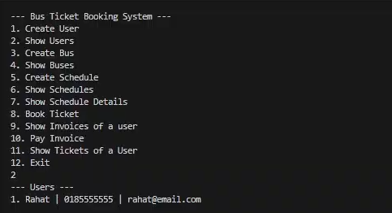

Show Buses:
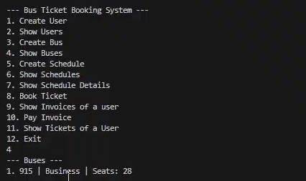

Show Schedules:
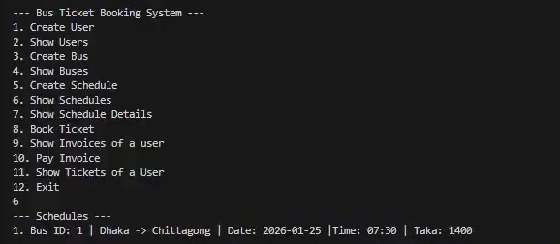

Show Schedule Details:
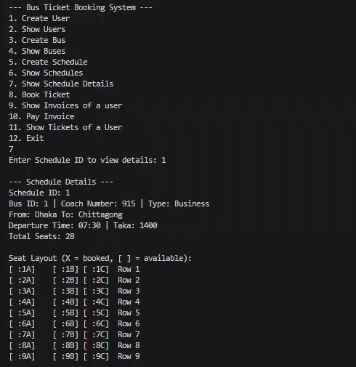

Book Ticket:
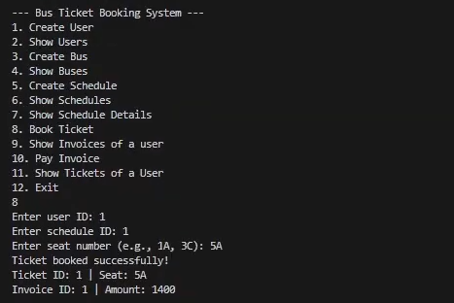
Show Tickets of a user
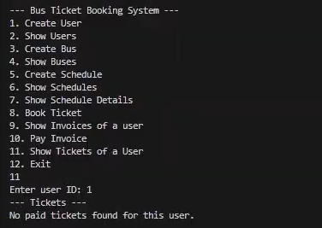

Show Invoices of a user
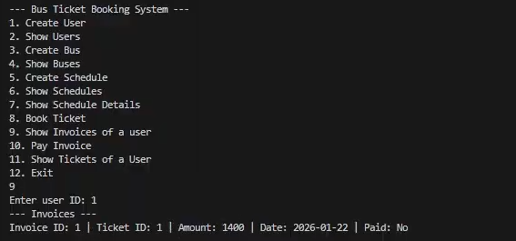

Pay Invoice
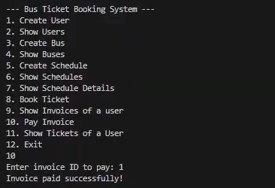

Show Schedule Details (after booking ticket)
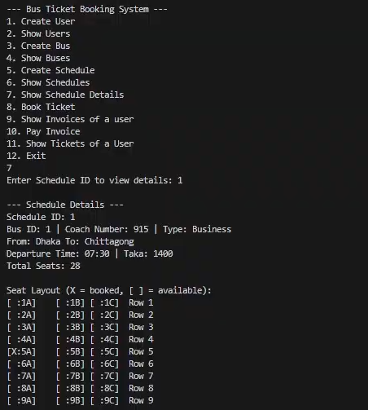

Show Tickets of a user
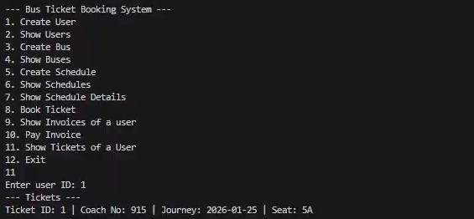

Show Invoices of a user (after payment)
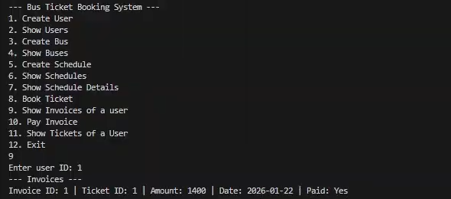
Book Ticket (which is already booked)
